Experiencing Antarctica
From Inspiration to Publication – bringing Antarctica to the masses

Wendy Pyper and Cathy Bruce

Some of you may be attending this talk because you’re expecting to see some great images of Antarctica. Well, I won’t disappoint you. As editor of the Australian Antarctic magazine, I’m lucky to have access to some of the best Antarctic photographers and images around. For example, this one of our icebreaker in a snow storm is one of my favourites.

But you were probably hoping to see something like this…
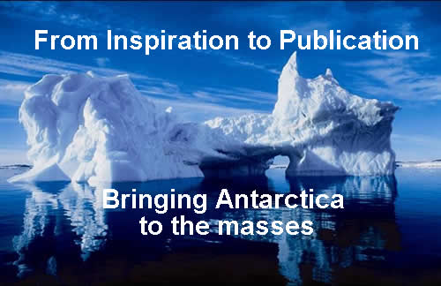

These sorts of images really appeal the imagination of so many because they capture the essence of Antarctica – a wild, beautiful and relatively untouched place that’s still very difficult to visit and experience. And people still think of it too in terms of the great feats of human endeavour and endurance by explorers such as Mawson, Shackleton and Scott.
It’s Cathy’s and my jobs to try and bottle this phenomenon that is Antarctica and present it to people sitting at their computers or in their lounge. So today we’re going to give you a bit of an insight into how we try and do that through the magazine and the website.
First, a bit of context…
The Australian Antarctic Division fulfils the Australian Government’s goals in Antarctica which are to:
- Maintain the Antarctic Treaty System and enhancing Australia’s influence within this system
- Protect the Antarctic environment
- Understand the role of Antarctica in the global climate system
- Undertake work of practical, economic and national significance.
It does this through the Australian Antarctic program, which is the whole package of science, policy and operational activities such as shipping and aviation.
My role as editor of the Australian Antarctic magazine and Cathy’s work with the Division’s web site, is to communicate to the public how the AAp is achieving these goals and why this work is important.
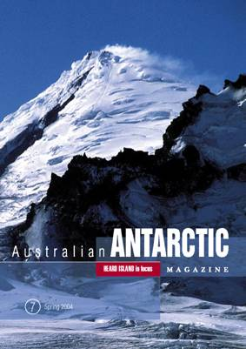

The Antarctic magazine has a circulation of about 4000, it comes out twice a year, and it has a very diverse readership which includes: politicians, scientists, doctors, media, educators, past expeditioners, museums, university libraries and departments, people involved in Antarctic aviation or shipping, other Antarctic or Arctic organisations.
The aim of the magazine is to inform the Australian and international Antarctic community about the activities of the Australian Antarctic program and we’re particularly keen to ensure that it is accessible to busy politicians, policy makers and scientists, who need to see results, or who can assist us in achieving the Government’s goals in Antarctica.
With this in mind articles are written in a popular, more accessible and entertaining style - sort of a cross between New Scientist and National Geographic. And the stories try to address the fundamental questions of ‘why is this work important’ and ‘why should anyone care’?
This is the process I go through to get from inspiration to publication which many of you will probably be familiar with.
Firstly, I
- Decide on a theme for the issue – this is usually done in consultation with the editorial committee
- Identify story ideas that fit this theme and potential writers
- Commission writers and provide them with an outline of what I want, article length and deadline
- Follow up with writers as the deadline approaches
- Research and write some stories myself
- Edit stories as they come in and pass them on to members of the editorial committee for independent scrutiny, proofreading and approval
- Find pictures and write captions
- Provide graphic designer with a brief of how I want the magazine to look and a rough idea of the story sequence
- Proofread the drafts that come back from the designer
- Organise printing and mailout
- Distribute magazines in house
- Organise electronic summaries of each story and pdfs to the full story on the website
- Breathe
- Start again
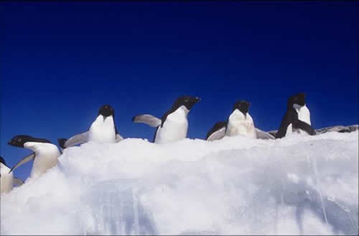

Photographer: Grant Dixon
I’d like to talk about some of the skills I’ve found I need as an editor to get from inspiration to publication, and also some of the things I’ve learnt along the way. I apologise to those experienced editors out there if this is fairly basic, but if the ideas aren’t new hopefully the perspective will be.
So, two of the core skills I think a magazine editor needs are the ability to communicate and to be flexible about how you approach and manage things.
For me communication is about talking to all the people involved in the magazine production process frequently and clearly. It is important in terms of
- Inspiration – finding and canvassing ideas
- Getting people to write stories for you – to fill the magazine pages
- Developing and maintaining relationships with all those involved in the production process
- Accuracy – not just facts within a story but also dates, copyright, image credits and so on
- Gaining expert knowledge that you can use to your advantage
Flexibility is the give and take of ideas between the editor and all the other people involved in the production process, and the ability to think laterally about solving problems. It is important for
- Getting the job done – overcoming those barriers to publication that crop up
- Maintaining relationships with people you will need in the future
- Assisting people to make their stories/research accessible to others
I’ll expand on these ideas in the next few slides…
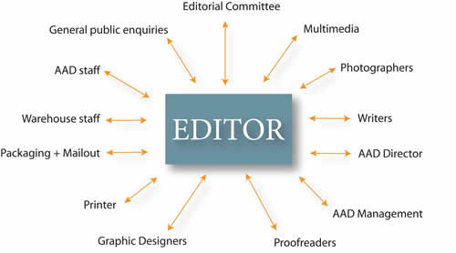
So the idea of communication may seem obvious and straightforward, but it can be quite hard to do, especially in such a diverse organisation as the Antarctic Division, because there are so many people coming from a range of different backgrounds and perspectives, with different agendas and with different priorities and time pressures, and many of them have different ideas about what should be in the magazine and how it should be presented.
This slide illustrates the range of people I talk to over the course of producing a magazine.
So I spend a lot of time listening to what people have to say, thinking about their ideas and balancing them with what I think is best for the magazine, and then working with people to come to a compromise in some cases.
Producing a magazine is a team effort and in order to maintain good relationships with all these people you need to communicate well and have a bit of give and take throughout the process.
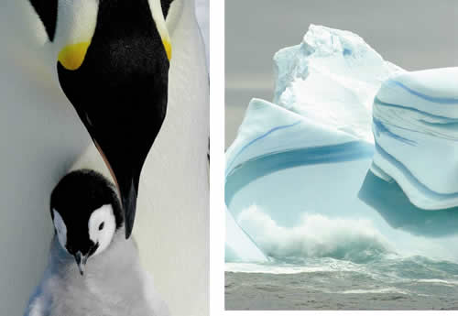
Photographers: Frederique Olivier, Steve Nicol
I don’t see myself as a dictator, telling people what to do, but rather as the person that guides and draws together all the ideas, creativity and expertise of others into a consistent and attractive package. I do try and retain a fair bit of control over the magazine content and layout, because I have the big picture of how it will all hang together, but I try not to micromanage every detail.
You really can’t do everything yourself because you’re not an expert at everything. You have to trust in the professionalism of others to get the job done well or use their ideas or advice to your advantage.
Of course sometimes things go wrong, even when you think you’ve done everything right, or issues crop up unexpectedly that you may never have anticipated. In Antarctica they call this the ‘A’ factor, but I’ve decided to coin a new phrase – the ‘E factor’ for editors.
This slide demonstrates the sort of treacherous terrain an editor sometimes has to navigate to get from inspiration to publication – you can get stuck part way or things will break up around you – you have to go back to your map and plot a new route or find someone to help you out … I’m sure there are hundreds of analogies you could draw but there are just a few.
Here’s one example of the E factor in action, but this problem was overcome through communication and thinking flexibly. As an editor it’s also a nice example of how we can help scientists, or others, make their research more accessible.
The oceanic model in AusCOM is the Modular Ocean Model [MOM] 4p0d (courtesy of GFDL/NOAA). MOM is a primitive equation, ocean model with the generalised horizontal orthogonal coordinates discretized on an Arakawa B-grid [Griffies et al., 2002]. MOM4p0d is a z-coordinate finite difference code using a predictor-corrected scheme for tracer evolution, which yields an improved performance compared to the leap-frog scheme, at the same time reducing conservation errors to roundoff tolerances.
This is a paragraph from a much longer article I’d asked a scientist to write. My brief to her had been to tell me what research she was doing and why it was important and to write it for a lay person audience … using articles in previous issues as a guide.
One of the things about the Antarctic magazine is that I rely on people who may never have had the experience of writing for a popular magazine before. Most of our scientists are very good at communicating what they do but some don’t have that experience or skill. So it’s my job to help them make their science accessible.
But when I received this I couldn’t understand any of it, so I couldn’t even begin to edit it, and I was faced with the proposition of telling her I couldn’t use it.
Instead, I asked her to respond to a series of questions about her research via email and this worked really well. She responded in a much more relaxed manner and in a way I could understand and draw out the key ideas.
A new ‘coupled’ ocean-sea ice model will help researchers more accurately model how different components of the climate system interact, improving their ability to predict the effects of climate change.
I think some scientists get into their ‘I’m writing a science paper’ mode when you ask them to write a story, so they need a bit of help to break free of this training.
This is also an example of where you can’t assume someone else understands what it is you want. It’s important to give writers or designers or whoever, examples of what you want, and encourage them to seek your advice if they’re struggling. In the case of writers, it may even be better to interview them yourself, write the story and then work with them to ensure their messages are included.
I’ve found that many of my editing problems come down to miscommunication – where you think or assume someone has understood what you’re requesting of them, and it turns out that they haven’t. So the other thing I’ve learnt is that, within reason, don’t assume that your idea, especially if it is a complex one, can be accurately transferred from your head to another’s. It’s best to write down your ideas in an email or draw your design concepts, and meet regularly or communicate often with the person whose skills you need, to ensure your vision becomes theirs. … You should also keep a paper trail of your ideas, meetings, requests etc to refer back to if things go really wrong.

List of tips
So what can we glean from all that.
- Well, firstly, you can’t do everything yourself, so take advantage of expert knowledge and skills to get the job done.
- But remember, we’re all human and sometimes mistakes, accidents, or the ‘E’ factor happen. So keep those lines of communication open and always double check your facts.
- When things go wrong, it’s important to acknowledge and correct your mistakes and learn from them.
- Write things down, so that you have something to refer to if things go wrong.
- And finally, you should always have a backup plan. If a story doesn’t materialise or you suddenly can’t use an image because you discover you don’t own the copyright, and so on, you need something to fill the gap.
It’s really just risk management – where you try and think of all the things that could go wrong and then put in processes and backups to prevent them happening or to deal with them if they do.
I just want to touch on a few more points before Cathy takes over.
First accuracy. The AAD is a government and a scientific organisation, so the magazine stories have to be accurate on both these fronts. We need to make sure that articles don’t contradict the stated government position on an issue, and we also need to ensure that by explaining complex scientific concepts in lay persons language we don’t change the scientific meaning of something. Again this comes down to communication and thinking laterally about how to present something.
Of course it’s essential to double check dates and names and so on. I have a small team of people who proofread my editing job and pick up things I’ve missed. But I find that proofreading the magazine draft that comes back from the graphic designer is one of the best times to double check those small details because you can see it all in print and you’ve usually had a break from the work for a week or two so you can look at it with fresh eyes.
Acronyms – the AAD loves acronyms and I think our scientists spend quite a bit of time coming up with new and amusing ones. We’ve had things like BROKE, FIBEX, BIOMASS and KAOS. Sometimes people only know a project by its acronym and don’t know what the acronym stands for. But you know yourself, as a reader, that acronyms can be a real pain, especially when there are a lot of them. So my policy now is to only use acronyms when they’re used repeatedly throughout the article and the thing they stand for is sufficiently wordy.
Finally overediting. As I’ve gained more experience as an editor I’ve started to think more about ensuring that when I’m editing a story I’m not editing my voice into it and the contributors voice out of it. So I’ll edit out passive voice or clumsy sentences, but I won’t rewrite a sentence just because I think my way of saying something sounds better.
It’s a very subjective thing, and contributors may still feel like you’ve hijacked their work even if you’ve been careful.
But I think it’s really important to be aware of and to aim for a situation where contributors retain a sense that the finished product it is still their own work. The idea is to help make the article better, rather than rewrite or restructure it completely.
Unless of course you get something along the lines of the example I showed you, in which case you need to find a more dramatic diplomatic solution. But ultimately it all comes down again, to communication and flexibility.
This is a real icebreaker in a snow storm.

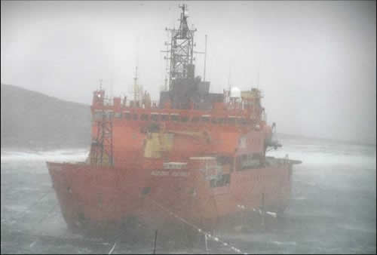
Photographer: Alison Lester

